

**3 Learn**

developed by Ho Wai Kin Sam in course COMP4521

User Guide

Name: Ho Wai Kin Sam

Student ID: 2044 7589

Email: [wkhoae@connect.ust.hk](mailto:wkhoae@connect.ust.hk)

**Table of Contents**

1. System requirement
2. Getting started

2.1 Login Page

2.2 Registering an account

2.3 Activating the account

2.5 Logging into the account

1. Dashboard
2. Building a note together with a quiz
3. Grabbing a note from market
4. Reading a note
5. Taking a quiz

**1. System requirement**

3 Learn requires android version 2.3 or above for the app to run properly on mobile phone.

**2. Getting started**

3Learn is an e-learning platform that promotes free-of-charge learning through knowledge exchange between users. It has 3 major components, including building your own learning materials, reading others’ learning materials and taking quizzes. Via this app, everyone can build their own learning materials and the related questions and publish them to the market. People can search the topics they are interested on the market and download the materials. After they have studied the material, they can do the quiz corresponding to that material. Through this app, people can share their knowledge to others.

**2.1 Login Page**

To use the app, every user needs an account. If the user has not signed in, the app will guide them to the login page. The Login Page is the entry point for registering an account, logging into an account and resetting an account’s password.

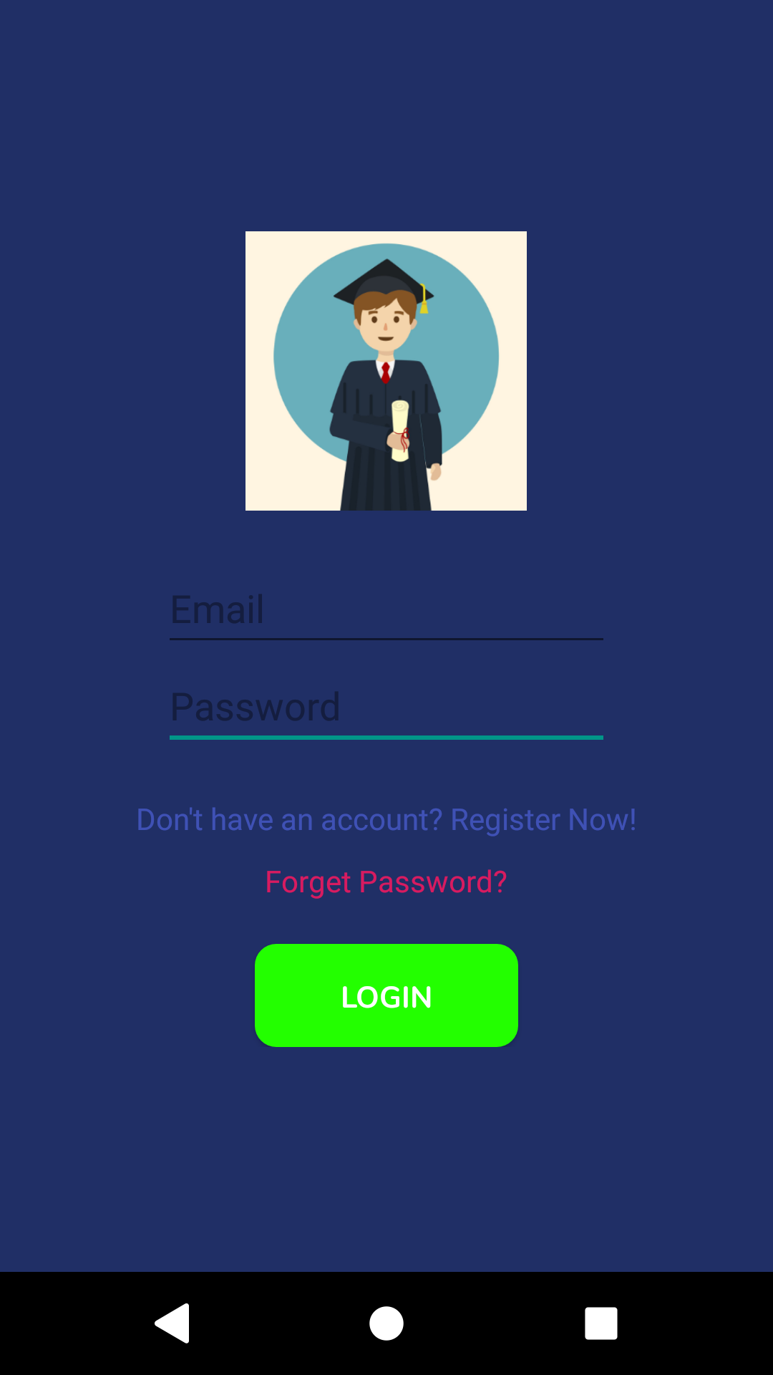

**2.2 Registering an account**

To create an account, you need to fill in the necessary information.

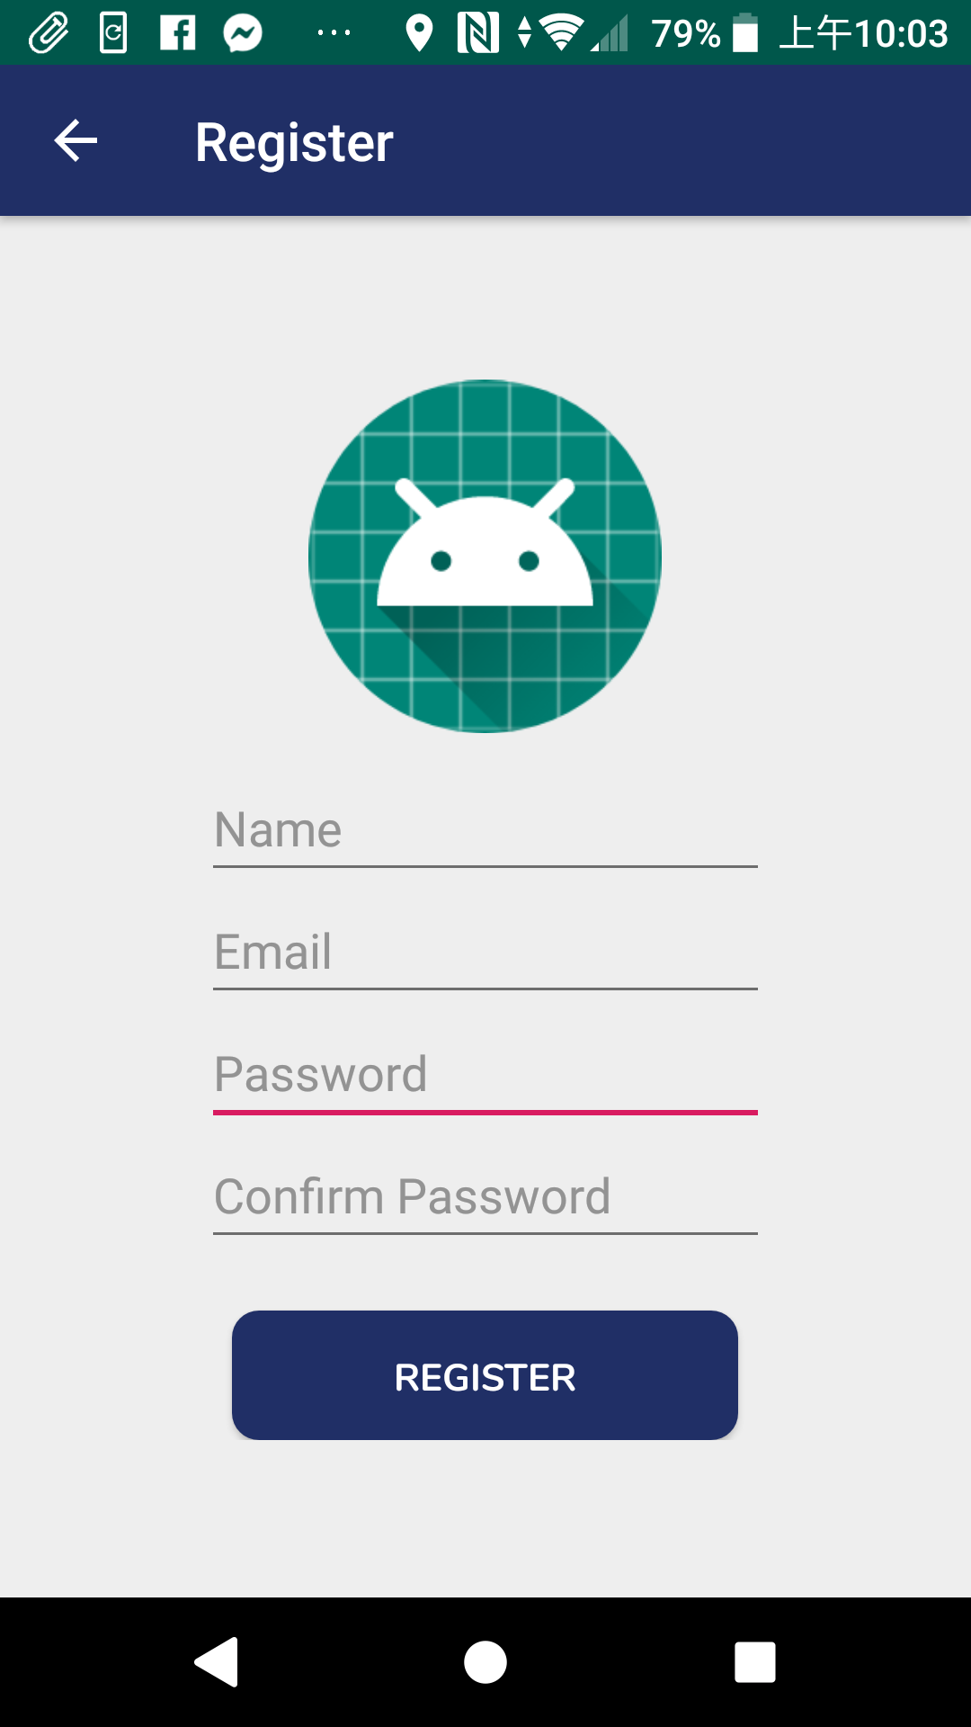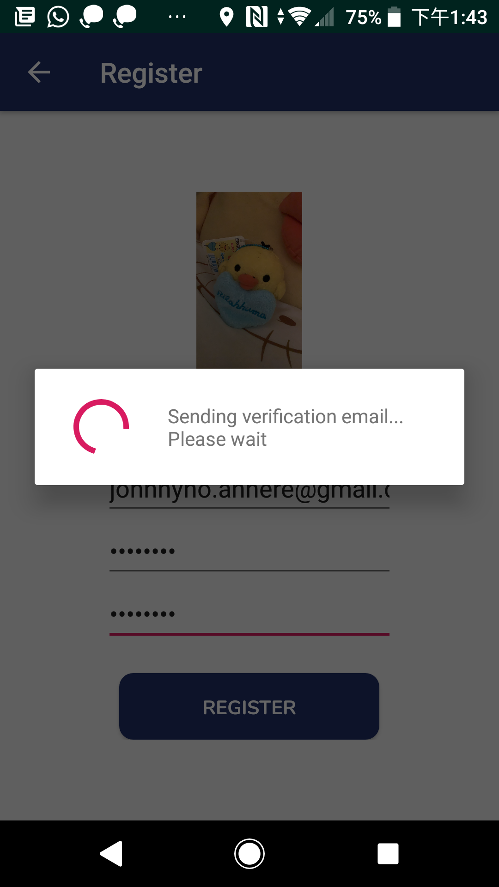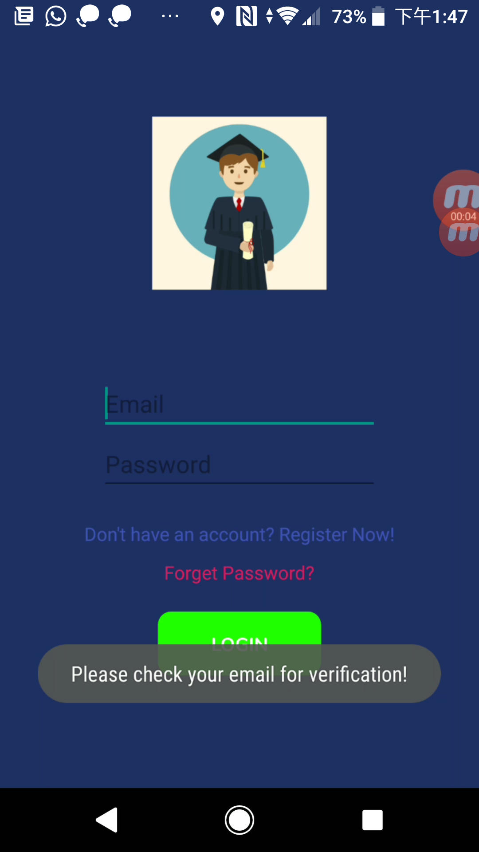

Steps:

1. Tap on “Don’t have an account? Register Now!” link in the Login Page and you will navigate to the Registration Page
2. Tap on the little green robot icon
3. Select a photo from your gallery as your profile picture
4. Fill in the user name, email, password and confirm password fields
5. Press “REGISTER” button. The system will send a verification email to your email account and navigate back to the login page

**2.3 Activating the account**

You need to activate the account before it can be used.

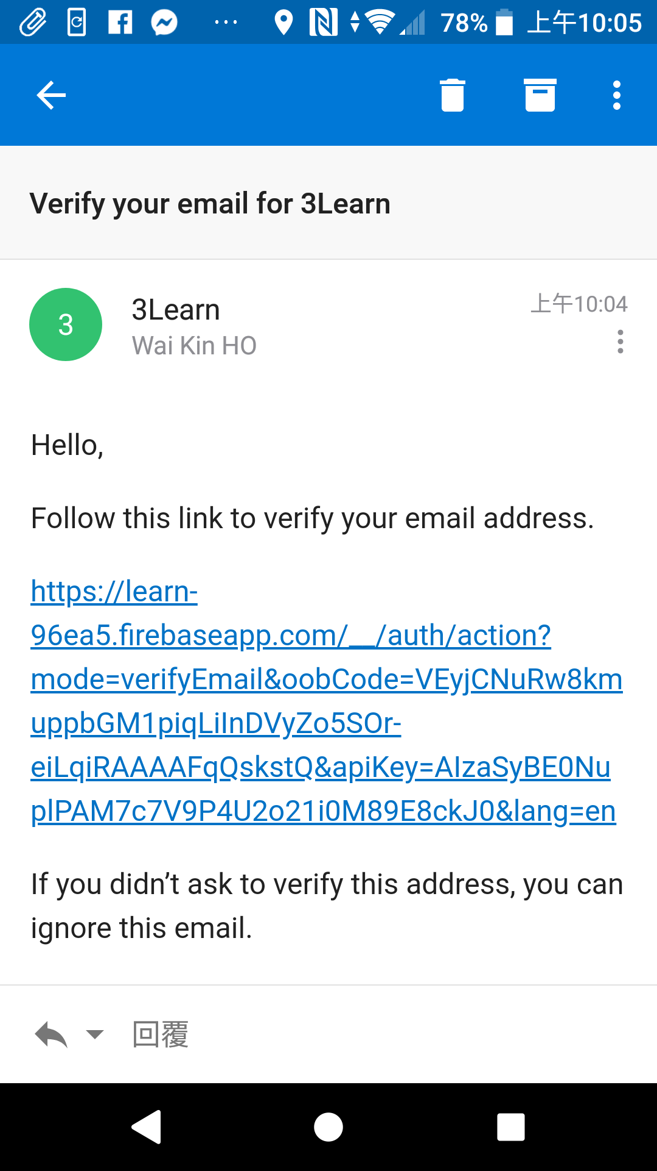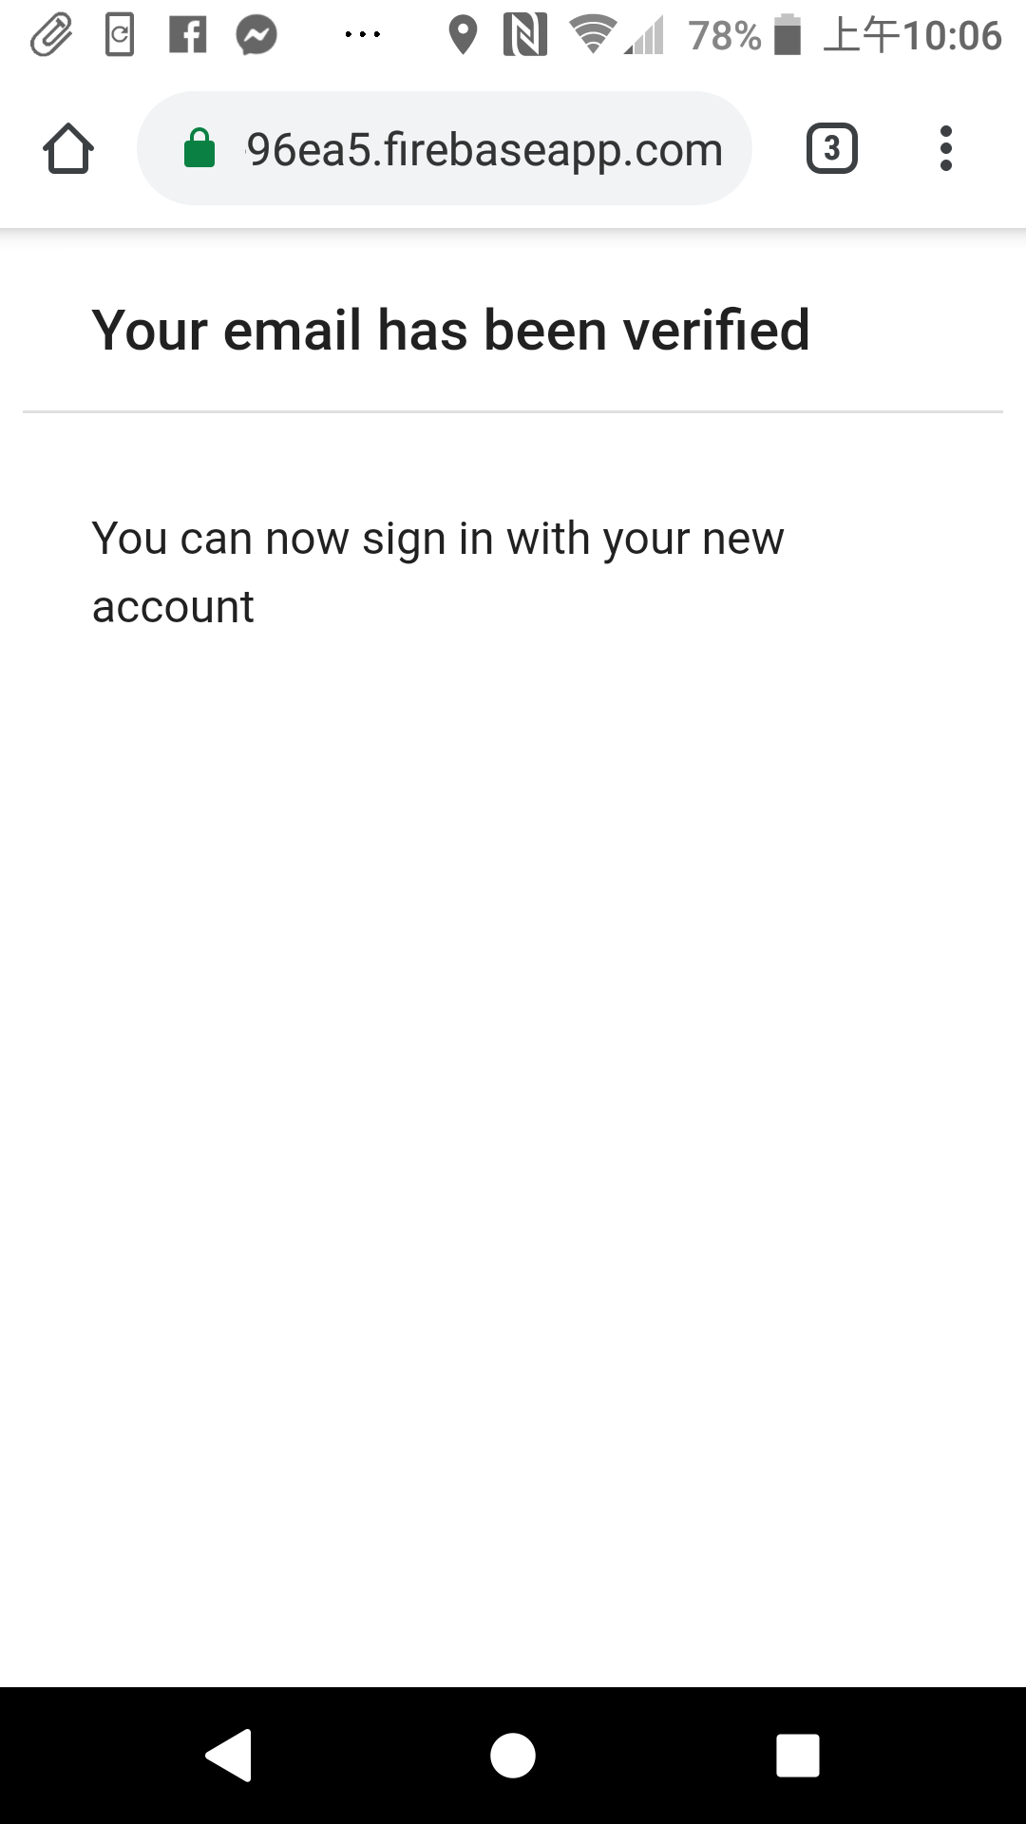

Steps:

1. Open your mailbox and your will see a verification email sent by 3Learn
2. Tap on the link in the verification email and the account will be activated successfully

**2.4 Logging into the account**

After registration and activation, you can now login your account and start using the platform.

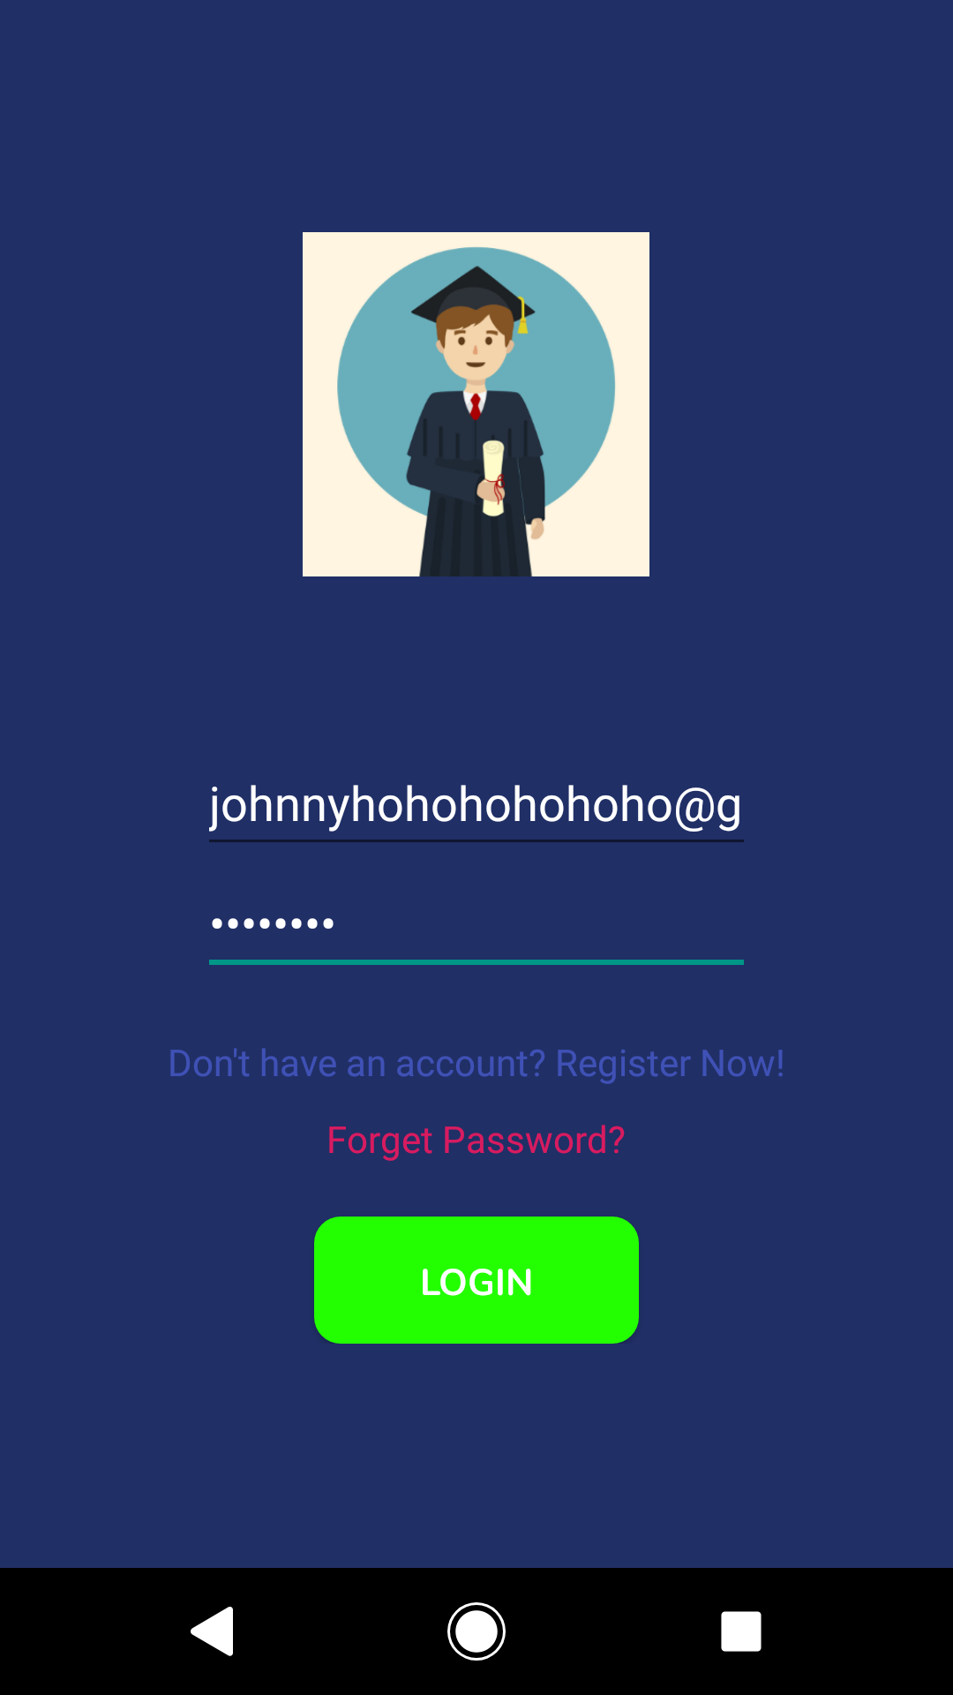

Steps:

1. Fill in the email and password fields of the account in the Login Page
2. Press the green “LOGIN” button. The system will bring you to the Dashboard and you are ready to go

**3. Dashboard**

This is the main page of the app. You can access to the build note, download note, read note, do quiz and edit profile functions here. On the top left hand corner, It shows the number of notes your account currently have and also your profile picture on the right hand side.

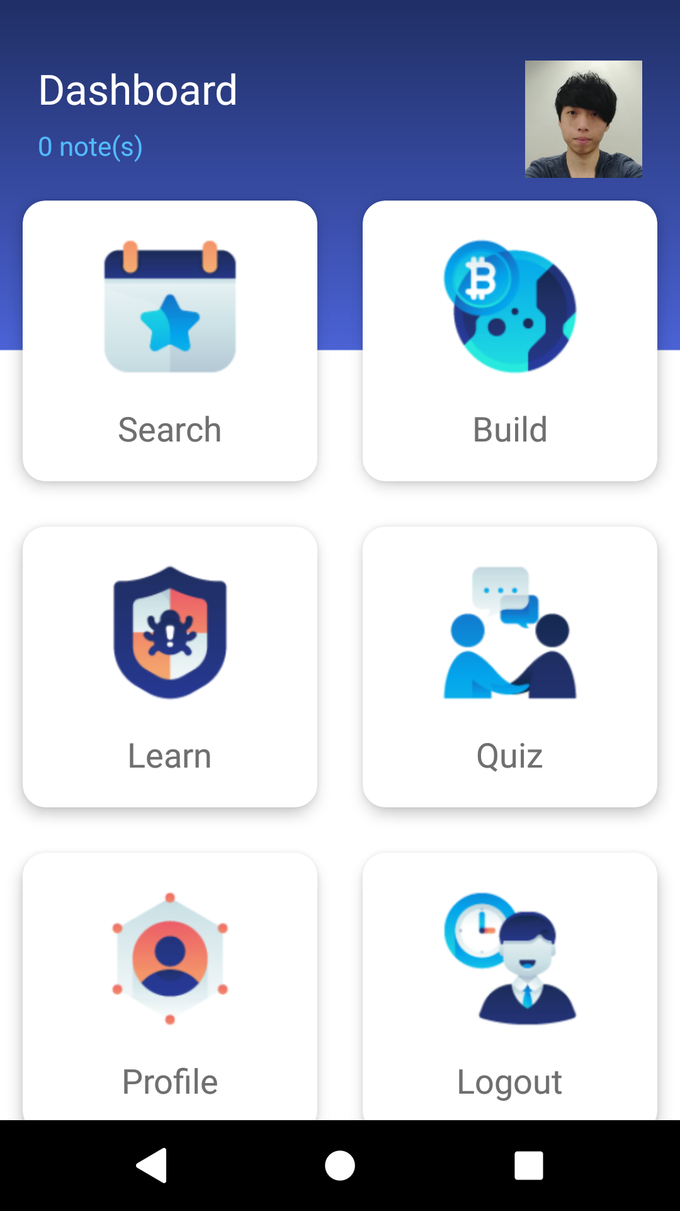

**4. Building a note together with a quiz**

A note can be made of multiple sections. It should have at least one section and at most ten sections. Each section should include heading and content.

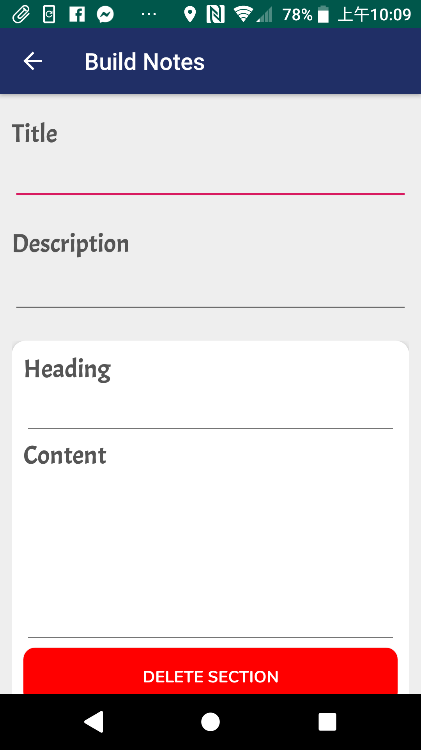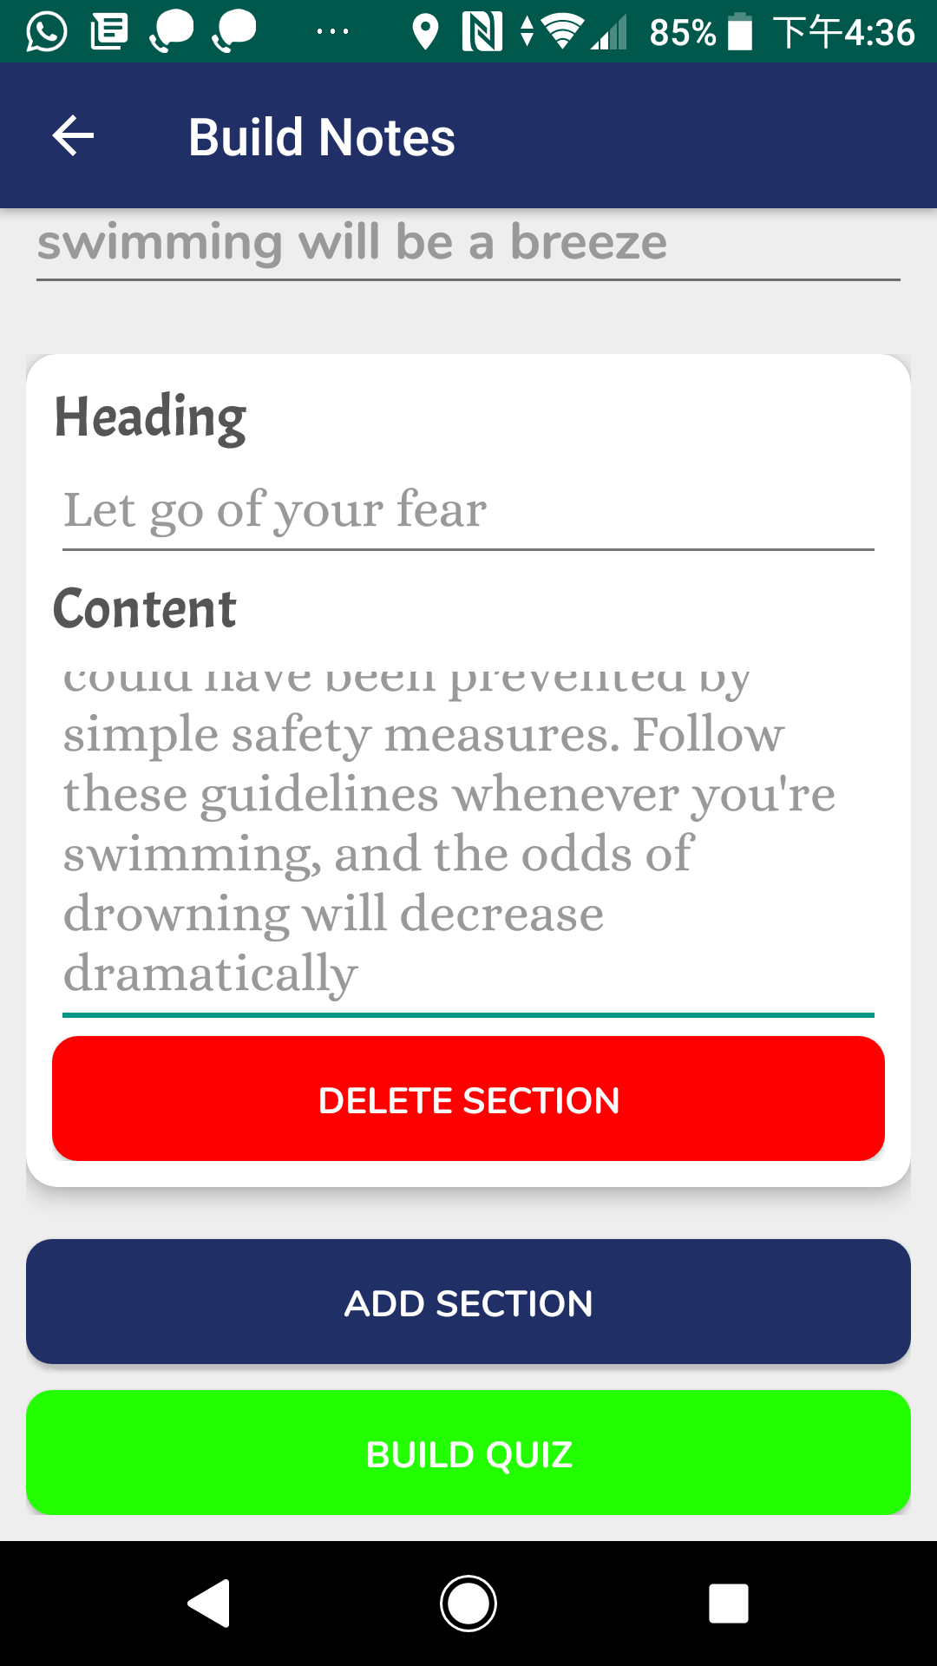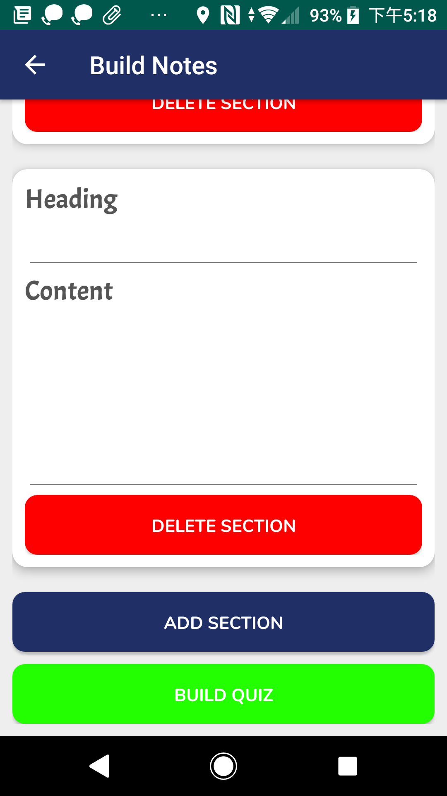

Steps:

1. Select “Build” card in the Dashboard and it will bring you to the Build Note page. If you want to go back to the Dashboard, you can press the arrow on the top left hand corner
2. Enter the note title and description for your note
3. Fill in the heading and content of the first section
4. If you want to add a new section, press the blue “ADD SECTION” button. A new empty section will then pop up under the last section.
5. If you want to remove a particular section, press the red “DELETE SECTION” button inside that section. The corresponding section will then be removed.
6. Press the green “BUILD QUIZ” button after you have filled in all the required details and you are ready to build a quiz for the note

After building the note content, you have to build a quiz related to the note. The quiz should have at least one question and at most ten questions.

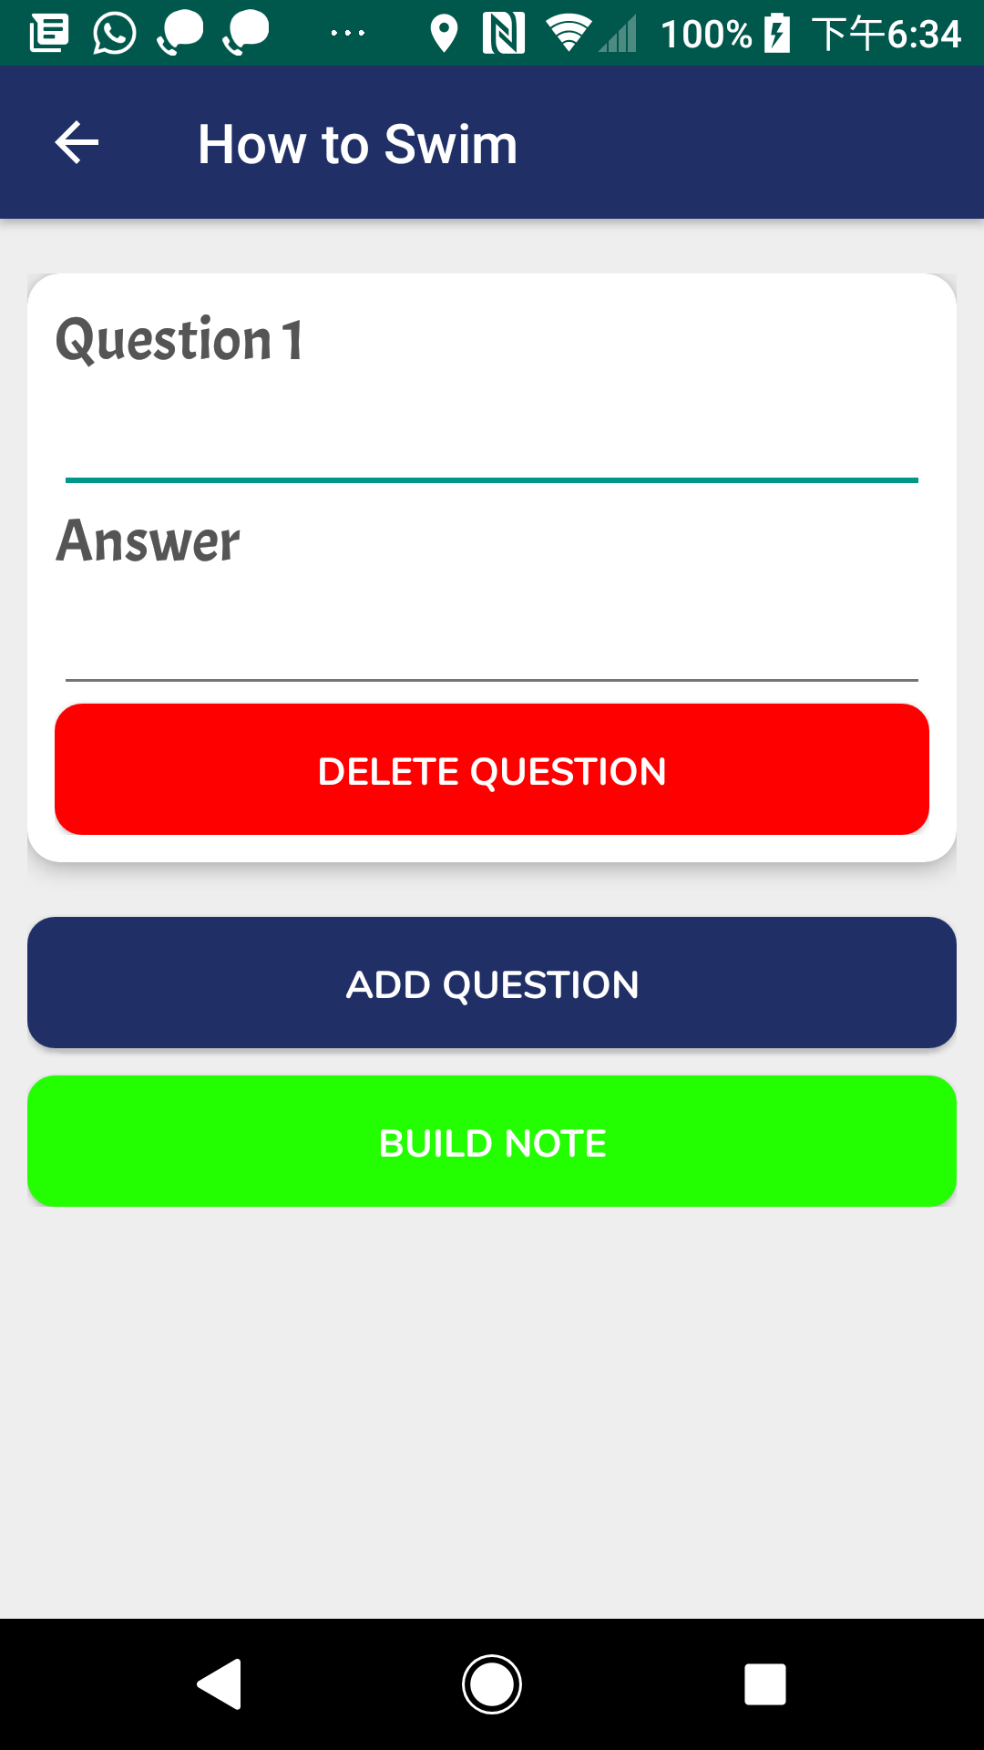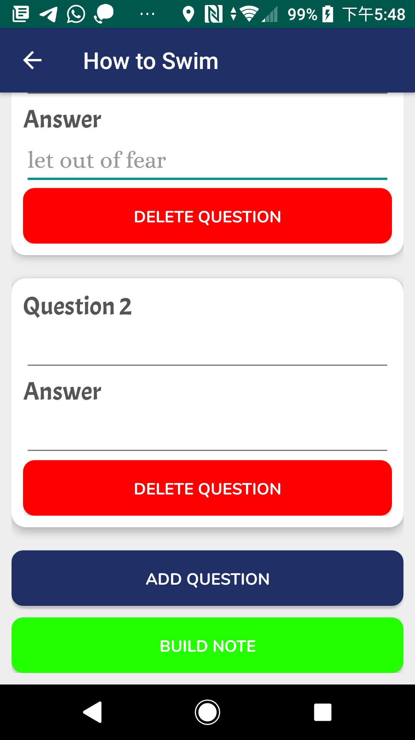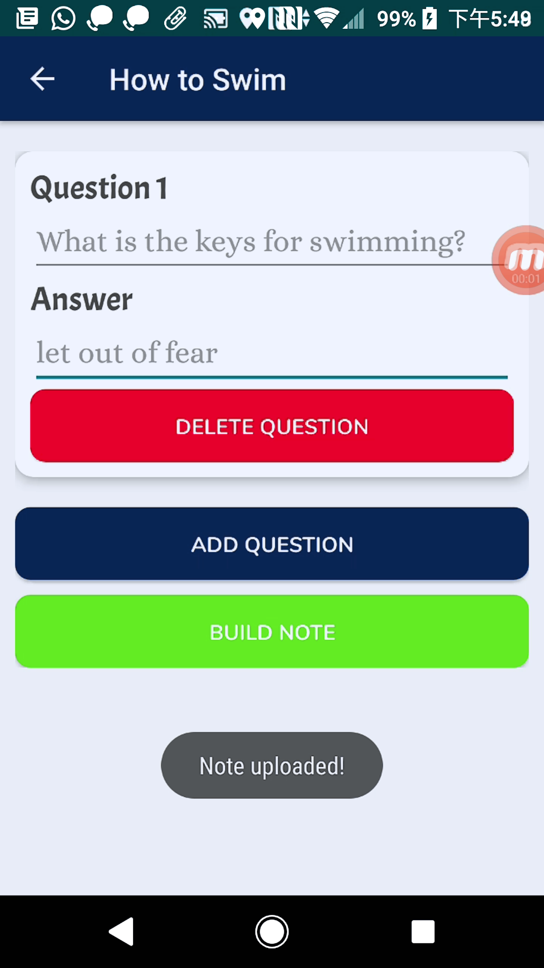

Steps:

1. To build a quiz, enter at least one question and answer pair for that quiz
2. If you want to add a question, press the blue “ADD QUESTION” button. A new empty question field will then pop up under the last question field
3. If you want to remove a particular question, press the red “DELETE QUESTION” button inside that question field. The corresponding question will then be removed
4. Press the green “BUILD NOTE” button after you have filled in all the blanks. The note together with the quiz will then be uploaded to the market. A notification “Note Uploaded!” will pop up at the bottom

**5. Grabbing a note from market**

The market contains notes that are uploaded by the users. You can search the note you want and download it.

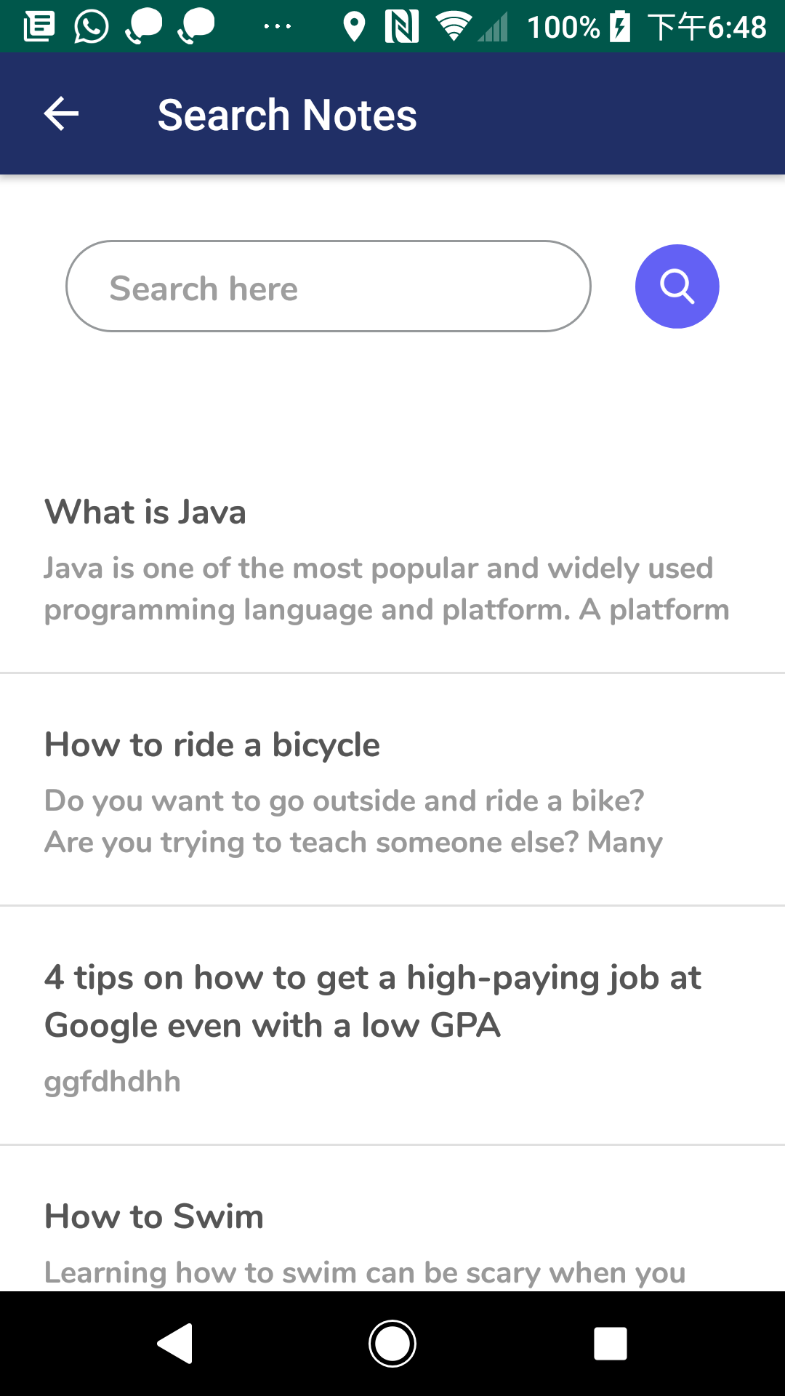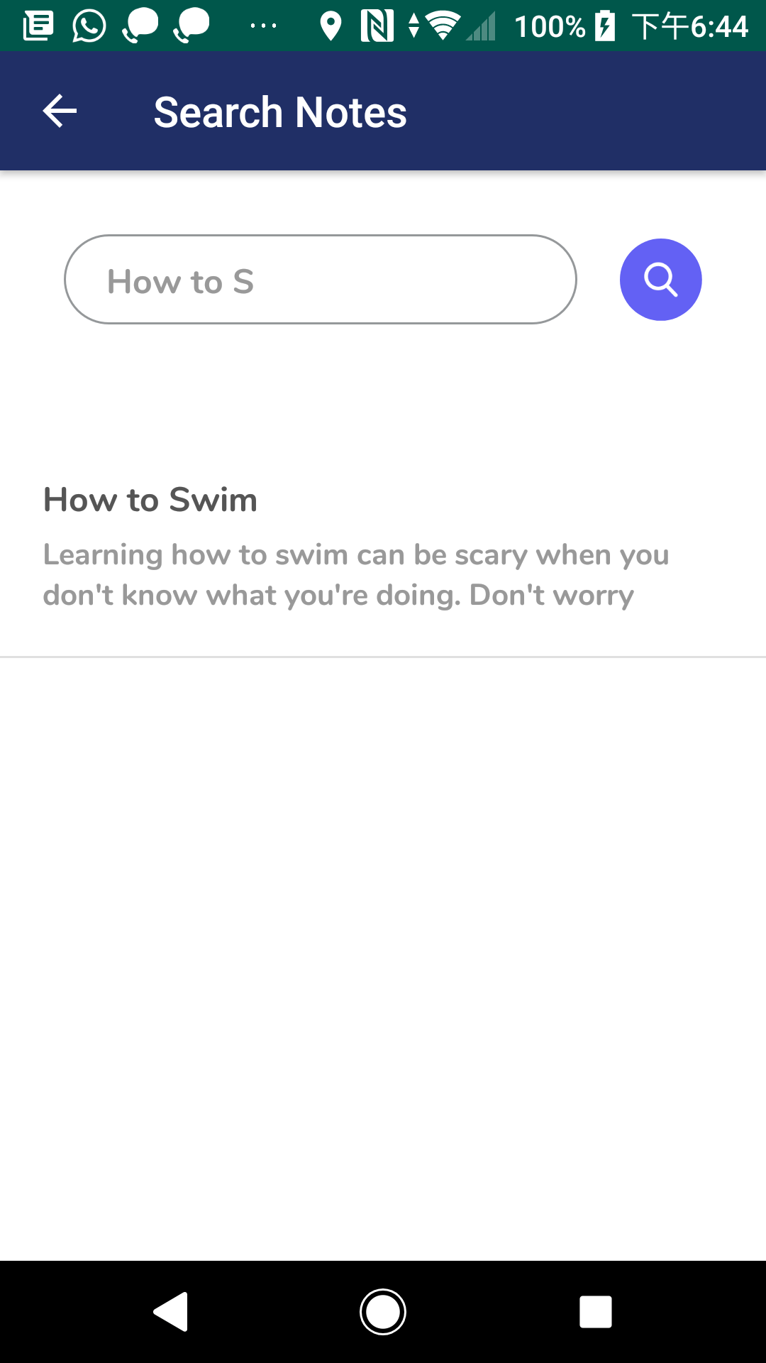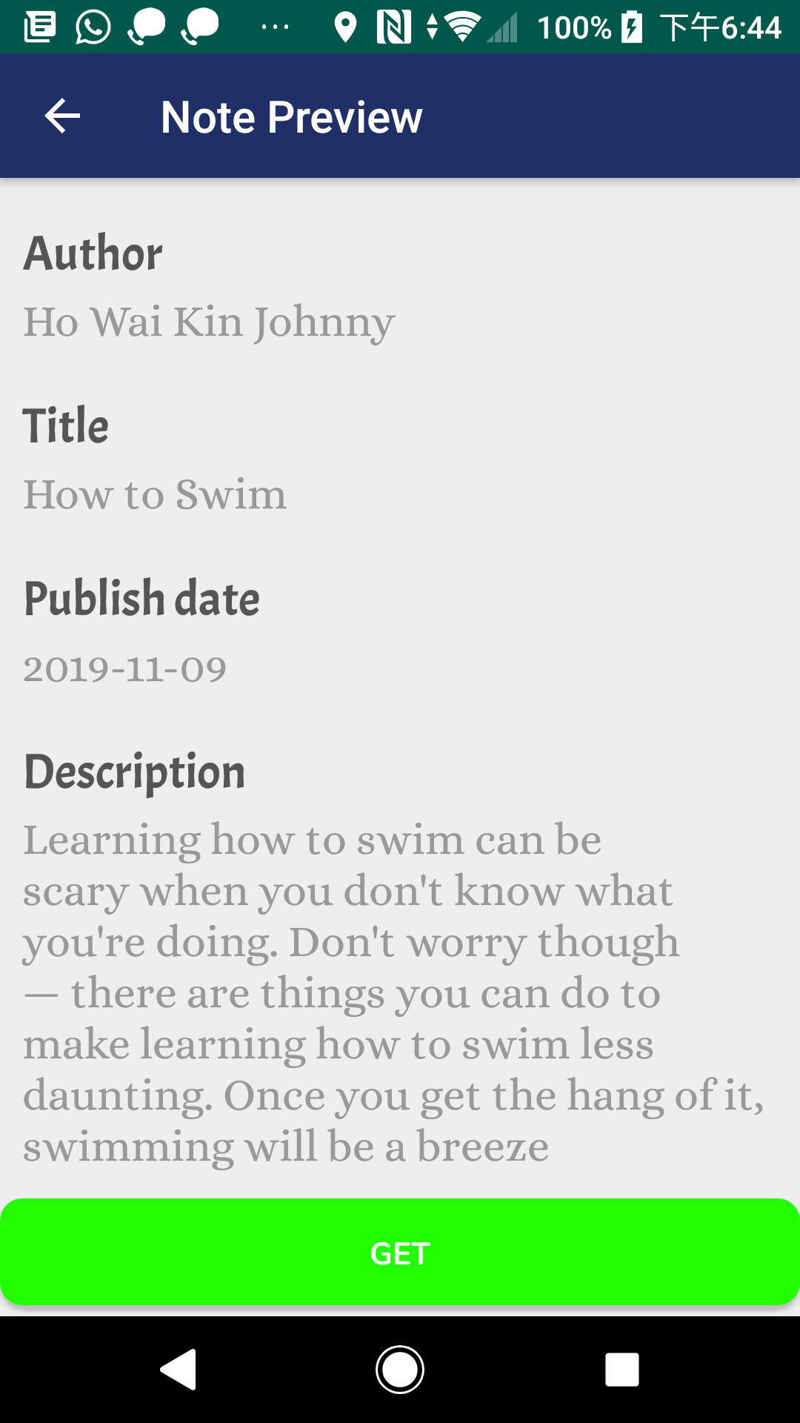

Steps:

1. Tap “Search” card in the Dashboard and you will be directed to the Market page
2. You can search notes by keyword. For example, you can type “How to S” in search bar and press the magnifier icon button. The note “How to Swim” will display
3. Select a note to preview
4. If you like this note, you can press “GET” button at the bottom of the Note Preview page. Then, the note will be stored into your account

**6. Reading a note**

You can go to your notes repository to read downloaded notes.

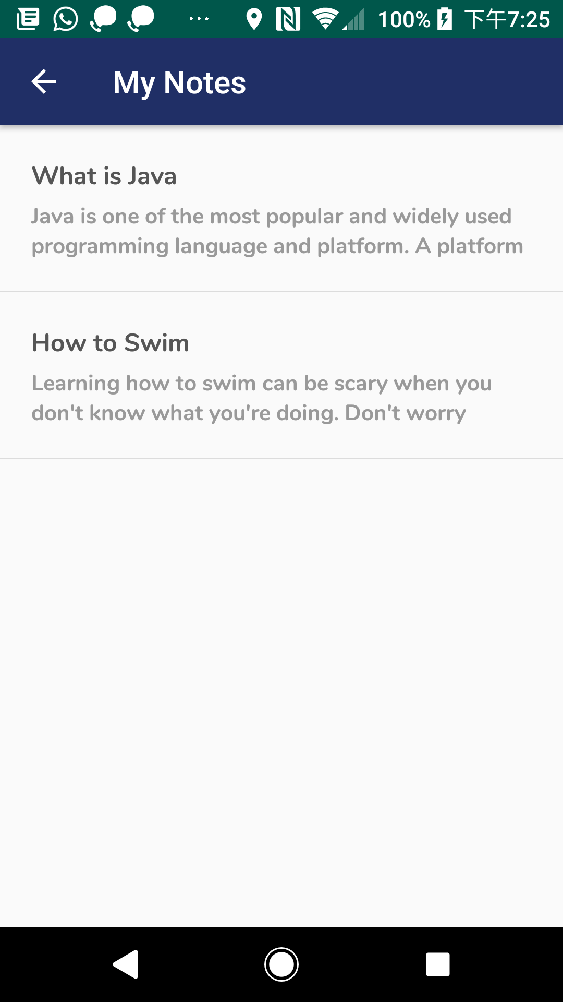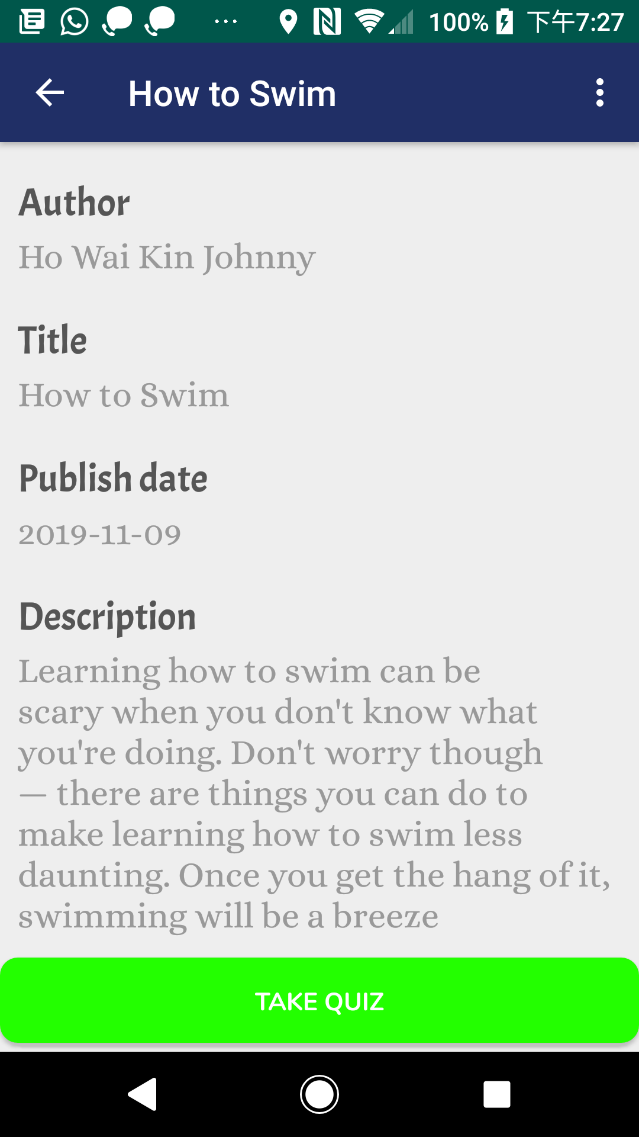

Steps:

1. Press the “Learn” card in the Dashboard and you will be navigated to your notes repository. It shows all the notes grabbed by you.
2. Select a note and start reading it
3. Press the “TAKE QUIZ” button at the bottom of that note if you want to test your understanding about the content of the note

**7. Taking a quiz**

You can take quiz by the following steps:

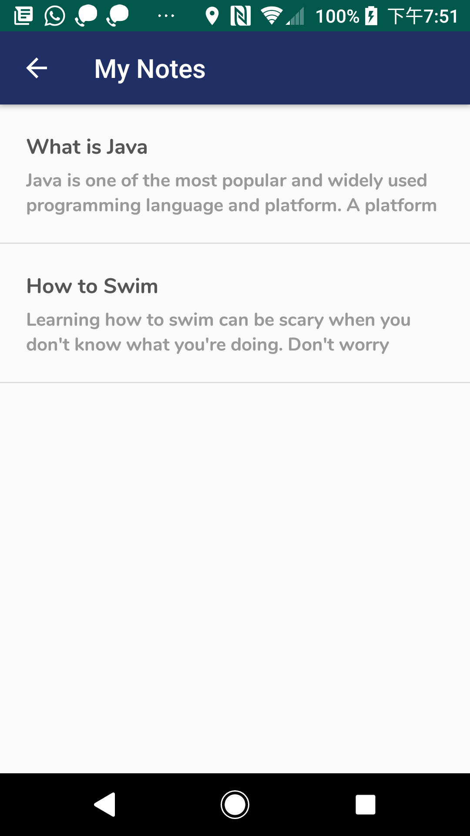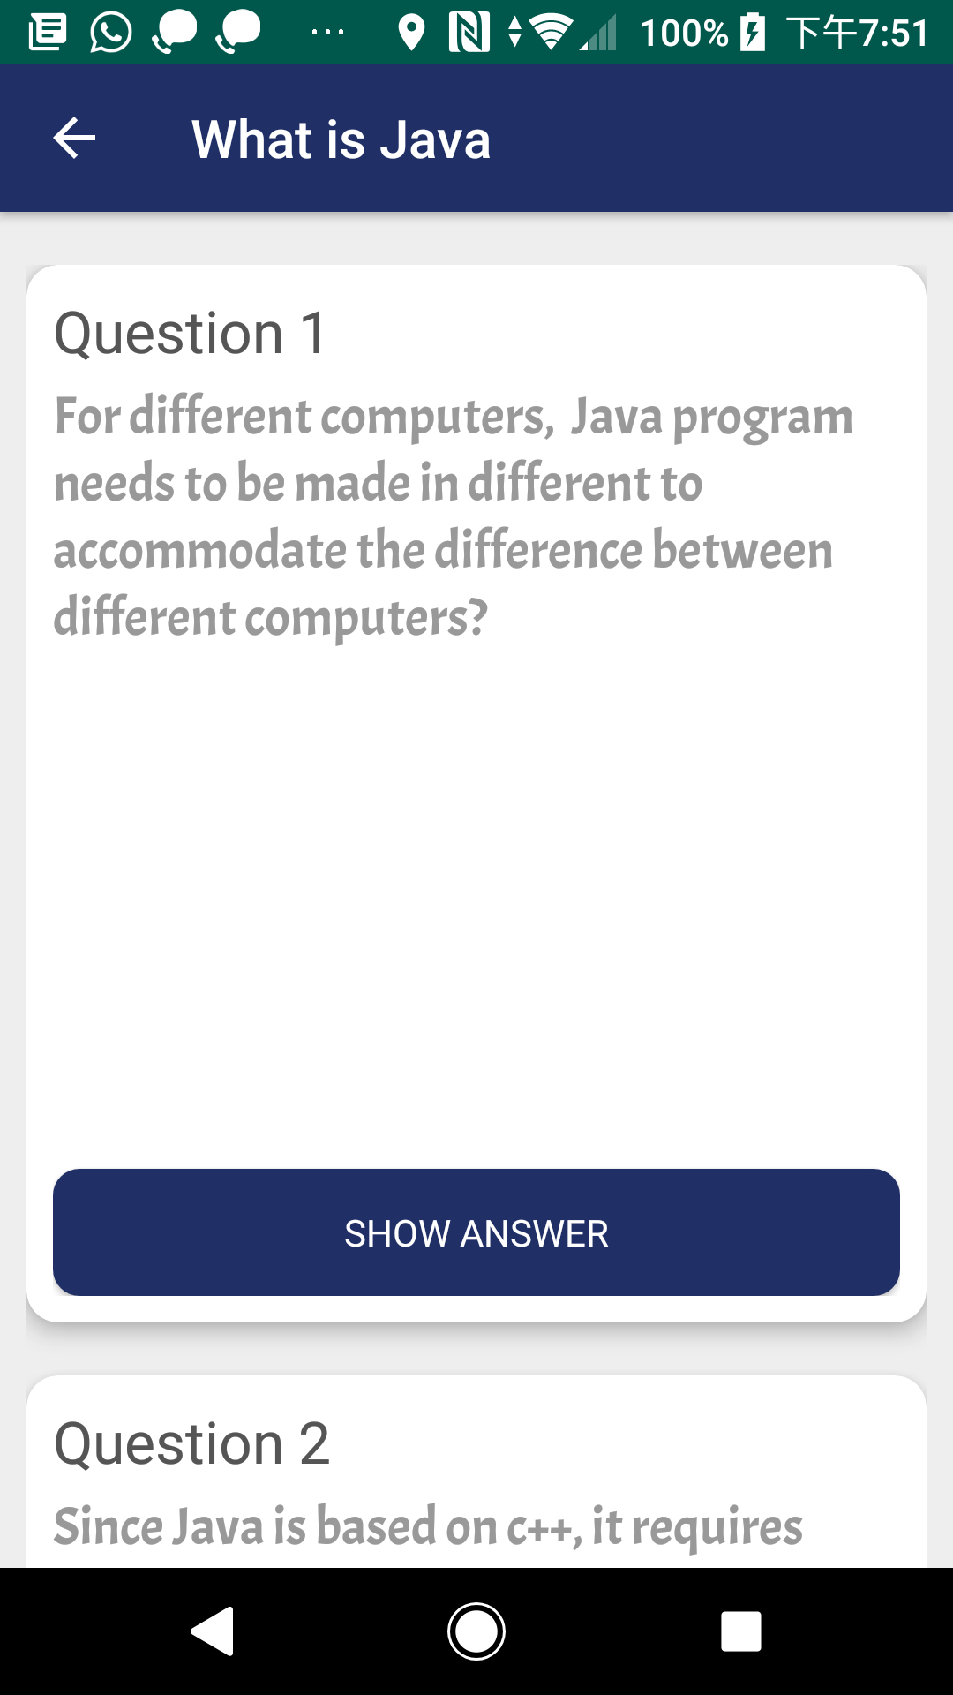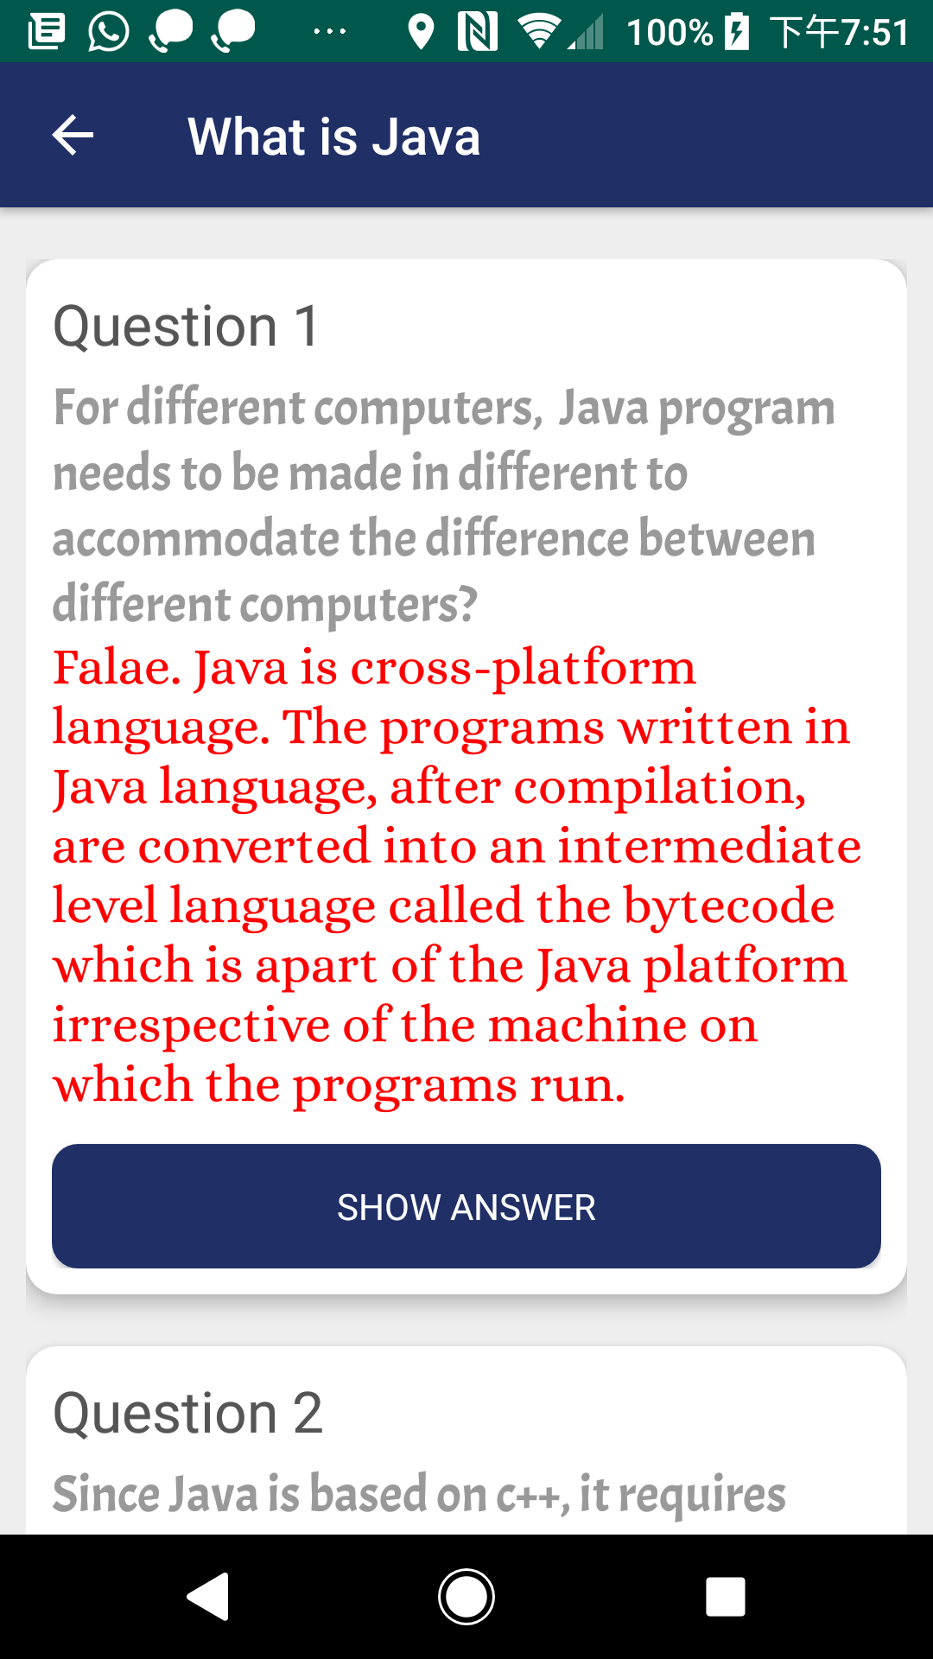

1. Tap the “Quiz” card in the Dashboard
2. Select a quiz of the note. Then, It will show you the questions of that quiz but the answers are all hidden
3. If you want to see the answer of a particular question, press the “SHOW ANSWER” button in that question field

(994 words)